Oracle 19c Installation on Linux with ASM in Standalone database

Installation oracle Linux 7.9 (OLE7.9.iso)

Steps

1 Prerequisites
2 Configure Oracle ASM
3 Install Grid Software
4 Configure ASM Diskgroups
5 Install Oracle Software
6 DBCA Create Database on ASM

Step1 .Prerequisites

Connect to OEL 7.9 server via putty and install the below packages
##Root
yum install -y oracle-database-preinstall-19c
yum -y install oracleasm*
yum -y install kmod-oracleasm*

Add below OS groups
##Root
groupadd -g 54327 asmdba
groupadd -g 54328 asmoper
groupadd -g 54329 asmadmin

Addasmdba as secondary group to Oracle user

usermod -a -G asmdba oracle

Create Grid User

useradd -u 54331 -g oinstall -G dba,asmdba,asmoper,asmadmin,racdba grid

Change the password for Oracle and Grid user

passwd oracle
passwd grid

Create the Directories for Oracle Database installation

mkdir -p /u01/app/oracle

mkdir -p /u01/app/oracle/product/19.3.0/dbhome_1

chown -R oracle:oinstall /u01

Create the Directories for Oracle Grid installation

mkdir -p /u01/app/grid/

mkdir -p /u01/app/grid/product/19.3.0/grid_home

chown -R grid:oinstall /u01/app/grid

chmod-R 775 /u01

Step2. Configure Oracle ASM

Let us configure Oracle ASM

oracleasm configure -i

Default user to own the driver interface []: grid
Default group to own the driver interface []: dba
Start Oracle ASM library driver on boot (y/n) [n]: y
Scan for Oracle ASM disks on boot (y/n): y
Writing Oracle ASM library driver configuration: done

Load / initiate Oracle ASM

oracleasminit

Creating /dev/oracleasm mount point: /dev/oracleasm
Loading module “oracleasm”: oracleasm
Configuring “Oracleasm” to use device physical block size
Mounting ASMlib driver filesystem: /dev/oracleasm

init 0

Add 30GB Harddisk

Add 30 GB HDD to virtual machine which we will use to create 3 partitions of 10 GB each for our ASM disks. Open Virtual machine >> Settings >> Storage >> Controller: SATA >> Create new disk
Fixed allocation.
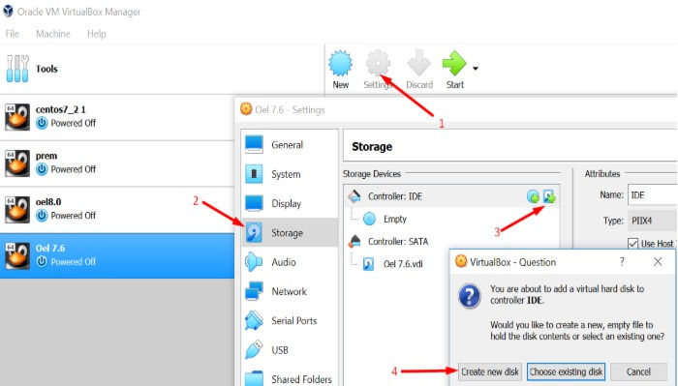

Click Next >> Next >> Give size 30 GB >> Click on Create

Start virtual machine and login as root user to format the newly added disk

fdisk -l

In the above output the/dev/sdb is not yet formatted. Let's create 3 partitions on sdb

fdisk /dev/sdb

n --> to create new partition
<enter>
<enter>
<enter>
+10G
n
<enter>
<enter>
<enter>
+10G
n
<enter>
<enter>
<enter>
<enter>

w --> to save partition table

step3. Create separate ASM Disk for each partition

oracleasmcreatedisk CRS1 /dev/sdb1
oracleasmcreatedisk DATA1 /dev/sdb2
oracleasmcreatedisk FRA1 /dev/sdb3

To check asm disks

Oracleasm listdisks

ls -lrt /dev/oracleasm/disks

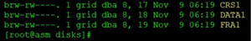

Step4. Install Grid Software

Edit Grid user Bash_Profile but take .bash_profile backup before editing it

From grid user
su– grid
cd $HOME
cp .bash_profile .bash_profile.orig

vi .bash_profile

Paste below contents
if [ -f ~/.bashrc ]; then
. ~/.bashrc
fi
ORACLE_SID=+ASM; export ORACLE_SID
ORACLE_BASE=/u01/app/grid; export ORACLE_BASE
ORACLE_HOME=/u01/app/grid/product/19.3.0/grid_home; export ORACLE_HOME
ORACLE_TERM=xterm; export ORACLE_TERM
JAVA_HOME=/usr/bin/java; export JAVA_HOME
TNS_ADMIN=$ORACLE_HOME/network/admin; export TNS_ADMIN

PATH=.:${JAVA_HOME}/bin:${PATH}:$HOME/bin:$ORACLE_HOME/bin
PATH=${PATH}:/usr/bin:/bin:/usr/local/bin
export PATH

umask 022

Save and close vi editor. Execute the bash profile and check the environment variables

. .bash_profile

env|grep ORA

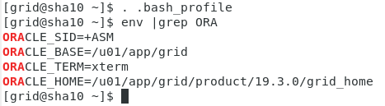

From Root

df -h

Unzip 19c grid software under grid home

cd $ORACLE_HOME

unzip linuxx64_12201_grid_home.zip-d /u01/app/grid/product/19.3.0/grid_home

##Grid
Start the gridSetup.sh which will install grid software
chown -R grid:oinstall grid

cd /u01/app/grid/product/19.3.0/grid_home
Grid_home>ll

./gridSetup.sh

Follow below screens to perform the grid software installation

- Change Disk group name as CRS
- Select External
- Click on Change Discovery Path
- Give Disk Discovery Path as /dev/oracleasm/disks
- Click on OK
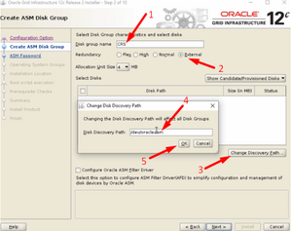
Select /dev/oracleasm/disks/CRS1 >> Next
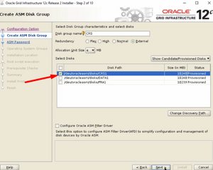

Select Use Same Password for these Accounts>> Specify password >> confirm password >> Next. Click on Yes

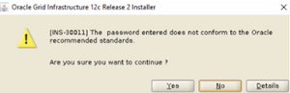
Click Next >> Next
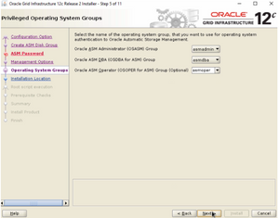
Click Next >> Next >> Next
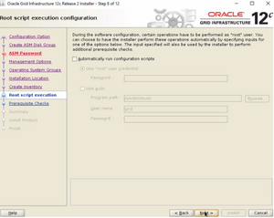
Click on fix and check again
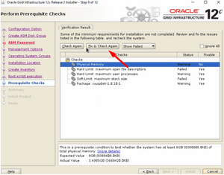
Copy script and paste into the Root User
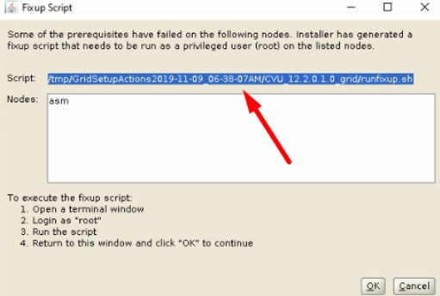
Click on OK >> Check Ignore All >> Click Yes
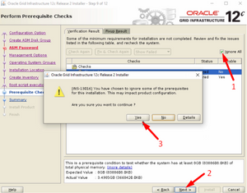
Click on Install and wait for installer to prompt root scripts
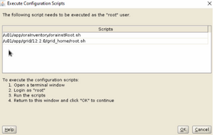
Click on Close
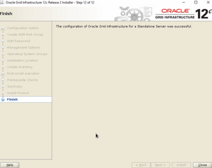

Configure ASM Diskgroups

The grid installer allows you to only create one diskgroup (CRS). We need to start the asmca utility in order to create DATA and FRA diskgroup which are required for database installation. Click on Create

cd /u01/app/grid/product/19.3.0/grid_home/bin
Bin>asmca

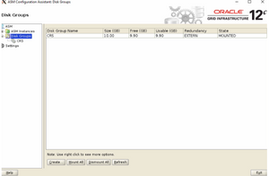

- Give Disk Group Name as DATA
- Select External(None)
- Select /dev/oracleasm/disks/DATA1
- Click on OK

Click on Create

- Give Disk Group Name as FRA
- Select External(None)
- Select /dev/oracleasm/disks/FRA1
- Click on OK
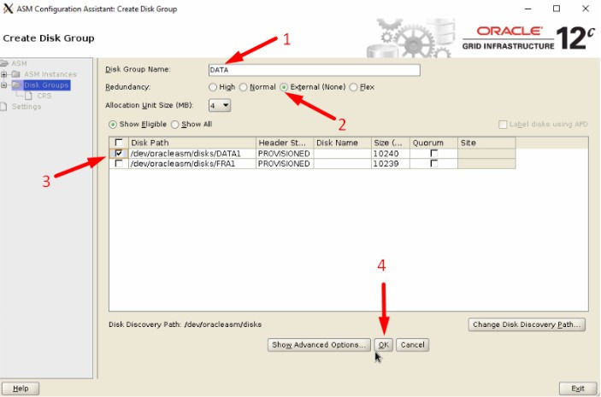

Exit >> Yes
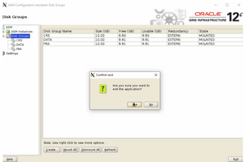

Step5 .Install Oracle Software

Edit Oracle user bash profile and put below
From oracle user

su oracle

cd $HOME

cp .bash_profile .bash_profile.orig

vi .bash_profile

if [ -f ~/.bashrc ]; then
. ~/.bashrc
fi
ORACLE_HOSTNAME=localhost.localdomain; export ORACLE_HOSTNAME
ORACLE_SID=orcl; export ORACLE_SID
ORACLE_UNQNAME=orcl; export ORACLE_UNQNAME
ORACLE_BASE=/u01/app/oracle; export ORACLE_BASE
ORACLE_HOME=/u01/app/oracle/product/19.3.0/dbhome_1; export ORACLE_HOME
ORACLE_TERM=xterm; export ORACLE_TERM

JAVA_HOME=/usr/bin/java; export JAVA_HOME
NLS_DATE_FORMAT="DD-MON-YYYY HH24:MI:SS"; export NLS_DATE_FORMAT
TNS_ADMIN=$ORACLE_HOME/network/admin; export TNS_ADMIN
PATH=.:${JAVA_HOME}/bin:${PATH}:$HOME/bin:$ORACLE_HOME/bin
PATH=${PATH}:/usr/bin:/bin:/usr/local/bin
export PATH

LD_LIBRARY_PATH=$ORACLE_HOME/lib
LD_LIBRARY_PATH=${LD_LIBRARY_PATH}:$ORACLE_HOME/oracm/lib
LD_LIBRARY_PATH=${LD_LIBRARY_PATH}:/lib:/usr/lib:/usr/local/lib
export LD_LIBRARY_PATH

CLASSPATH=$ORACLE_HOME/JRE:$ORACLE_HOME/jlib:$ORACLE_HOME/rdbms/jlib:$ORACLE_HOME/network/jlib
export CLASSPATH

TEMP=/tmp ;export TMP
TMPDIR=$tmp ; export TMPDIR

umask 022

Execute the Bash_Profile

. .bash_profile

Env |grep ORA

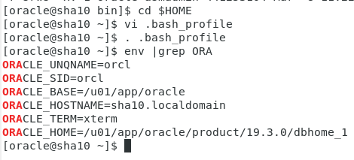

Unzip the Oracle software

Df –h

unzip linuxx64_12201_database.zip -d /u01/app/oracle/product/19.3.0/dbhome_1

cd /u01/app/oracle/product/19.3.0/dbhome_1/database

Start the runinstaller

cd database
./runinstaller
Uncheck the i wish to receive security updates via my oracle support
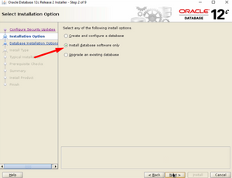
Select install database software only >> Next >> Next >> Next >> Next >> Next
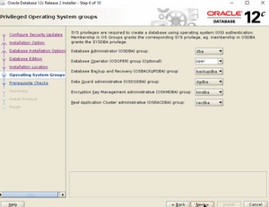
Click on Install
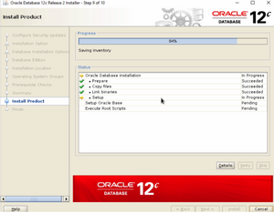
Run the Root scripts as root user
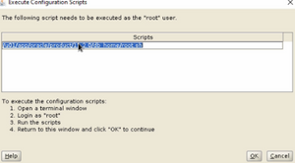
Close the installer.

Step6. DBCA Create Database on ASM

We can now go ahead and create database on ASM with DBCA. Start DBCA >> Create a Database >> Advance Configuration

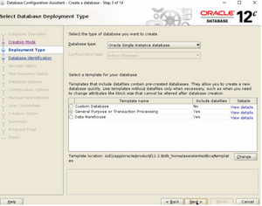
- Give Global Database name as prod
- Uncheck Create as container database
- Click on Next
Select Use following for the database storage attributes >> Browse
- Select DATA>> Click on OK
- Click on Next
Select specific fast recovery area >> Browse
- Select FRA >> Click on OK
- Change Fast Recovery Area Size >> Next
Click Next >> Next >> Next
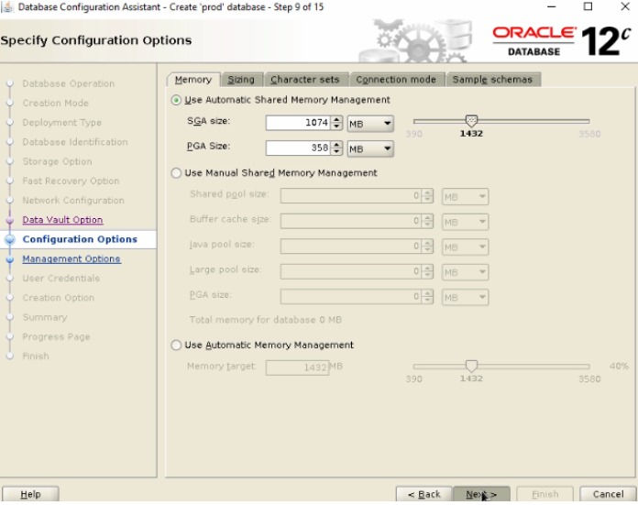
Uncheck Register with Enterprise Manager(EM) database express

Select Use the same administrative password for all accounts >> Password >> Confirm Password

Select Create the database>> Next >> Finish
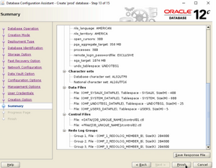
Done! For confirmation purpose, connect to database as Oracle user and issue below queries

SQL> select name, open_mode from v$database;

SQL> select name from v$datafile;

SQL> select name from v$controlfile;

We have successfully create Oracle Database on ASM!

.

DBCA Does Not Display ASM Disk Groups in 19c

Log in as root user

su root

cd /dev/oracleasm/

ls -lrt --> check permission on oracleasm directory

cd /dev

dev> chown -R grid:oinstall oracleasm

cd /dev/oracleasm/disks

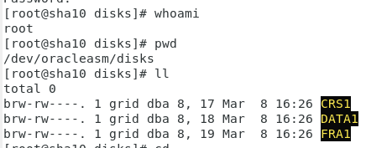

Login as grid user

su grid

cd $ORACLE_HOME/bin

ls -ld --> check permission on oracle directory

bin> chmod 6571 oracle

ls -ld oracle

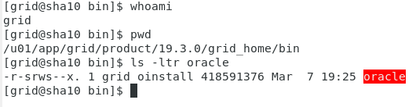

Login as oracle user

Su oracle

ls -ld oracle --> check the permissions

However, oracle directory permission in both grid user and oracle user must have the same permission. Therefore, issue the following command

Cd $ORACLE_HOME/bin

bin > chmod 6571 oracle

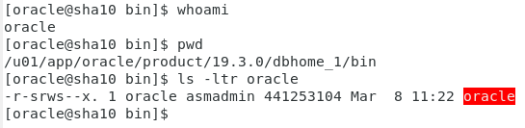

# init 6

Go back to select disk group and refresh!

